UNIT 1
- INTRODUCTION TO COMPUTER GRAPHICS
Computer graphics involves display, manipulation and storage of pictures and experimental data for proper visualization using a computer.
It provides methods for producing images and animations (sequence of images). It deals with the hardware as well as software support for generating images.
Computer graphics is a study of techniques to improve communication between human and machine. The word computer graphics means pictures; graphs or scene is drawn with the help of computer.
Graphics are visual presentations on a surface, such as a computer screen. Examples are photographs, drawing, graphics designs, maps, engineering drawings, or other images. Graphics often combine text and illustration.
- DEFINITION OF COMPUTER GRAPHICS

- BASICALLY, THERE ARE FOUR MAJOR OPERATIONS THAT WE PERFORM IN COMPUTER GRAPHICS:

- Imaging: refers to the representation of 2D images.
- Modeling: refers to the representation of 3D images.
- Rendering: refers to the generation of 2D images from 3D models
- Animation: refers to provide animated effects.

- NAME THE APPLICATIONS OF CG
- Engineering/scientific software , business software
- T.V channels, space simulation training
- PCB designing, map designing
- User interface, map preparation
- Making charts, image processing
- Office automation
- Desktop publishing
- CAD/CAM
- Art and commerce
- Process controlling
- Visual effects in movies and computer games

- APPLICATIONS OF COMPUTER GRAPHICS (EXPLAIN)
- Computer-Aided Design:
- In engineering and architectural systems, the products are modeled using computer graphics commonly referred as CAD (Computer Aided Design).
- In many design applications like automobiles, aircraft, spacecraft, etc.,
- CAD applications are also used in computer animations.
- Presentation graphics:
- In applications like summarizing of data of financial, statistical, mathematical, scientific and economic research reports, presentation graphics are used.
- It increases the understanding using visual tools like bar charts, line graphs, pie charts and other displays.
- Computer Art:
- A variety of computer methods are available for artists for designing and specifying motions of an object.
- The object can be painted electronically on a graphic tablet using stylus with different brush strokes, brush widths and colors.
- Entertainment:
- In making motion pictures, music videos and television shows, computer graphics methods are widely used.
- Education and training:
- Computer graphics can make us understand the functioning of a system in a better way.
- In physical systems, biological systems, population trends, etc., models makes it easier to understand.
- Visualization:
- For analyzing scientific, engineering, medical and business data or behavior where we have to deal with large amount of information, it is very tedious and ineffective process to determine trends and relationships among them.
- Image processing:
- Image processing provides us techniques to modify or interpret existing images.
- One can improve picture quality through image processing techniques and can also be used for machine perception of visual information in robotics.
- Used for CT (Computer X-ray Tomography) and PET (Position Emission Tomography) images.
- Graphical User Interface:
- GUI commonly used these days to make a software package more interactive. There are multiple window system, icons, menus, which allows a computer setup to be utilized more efficiently.
- IMAGE AND OBJECTS
An image is basically representation of a real world object on a computer.
- It can be an actual picture display, a stored page in a video memory, or a source code generated by a program.
- Mathematically, an image is a two - dimensional array of data with intensity or a color value at each element of the array.
- Objects are real world entities defined in three – dimensional world coordinates. In computer graphics we deal with both 2D and 3D descriptions of an object
- IMAGE REPRESENTATION
- Image representation is the approximations of the real world displayed in a computer.
- A picture in computer graphics is represented as a collection of discrete picture elements termed as pixels.
- A pixel is the smallest element of picture or object that can be represented on the screen of a device like computer.

- BASIC GRAPHIC PIPELINE
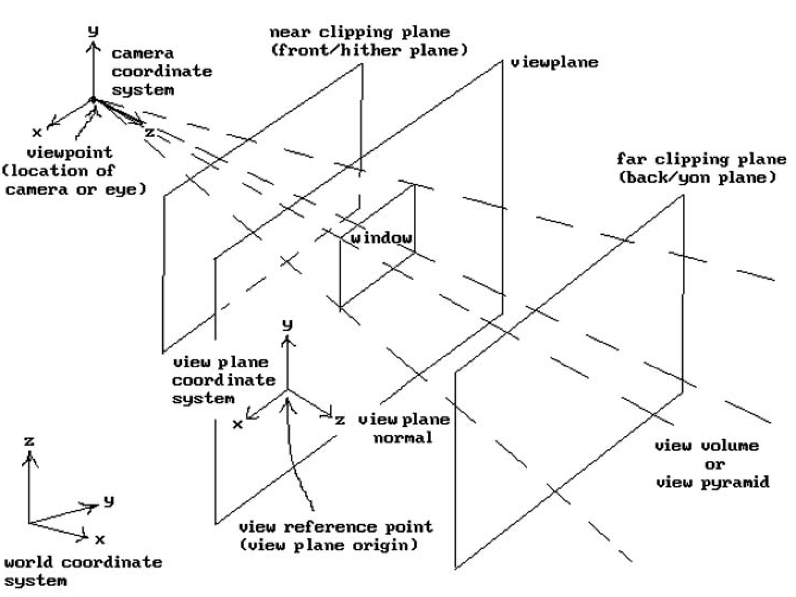
Several stages for graphic pipeline are:
- Modelling transformation: In this stage the 3D geometry provided as input is established is what is known as 3D world space-a conceptual orientation and arrangement in 3D space. Transformation on object space (translation and rotation).
- Per vertex lighting: vertices of the polygon being rendered. Per fragment (per pixel) lighting can be done.
- Viewing transformation: 3D world space to 3D coordinate
- Primitive generation: new primitives are generated from those primitives that were sent to beginning of the graphics pipeline.
- Projection transformation: eye space to the rendering camera into 2D image space, mapping the 3D scene onto a plane as seen from virtual camera.
- Clipping: means to clip (eliminate) the portion which is outside the window.
- Scan conversion or rasterization: Rasterization is a process by which the 2D image space representation of the scene is converted into raster format and the correct resulting pixel values are determined.
- Texturing, fragment shading: pipeline individual fragments assigned a color based values interpolated from vertices during rasterization or from texture mapping.
- Display: final colored pixels displayed.
- The graphics pipeline in hardware: rendering pipeline is mapped.

- IMAGE IS DIVIDED INTO BITMAP AND VECTOR – BASED GRAPHICS
- Bitmap graphics:
- It is pixel based graphics.
- The position and color information about the image are stored in pixels arranged in grid pattern.
- The Image size is determined on the basis of image resolution.
- These images cannot be scaled easily.
- Bitmap images are used to represent photorealistic images which involve complex color variations.

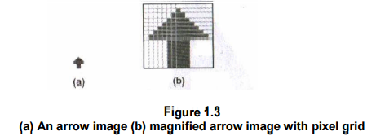

- Vector graphics:
- The images in vector graphics are basically mathematically based images.
- Vector based images have smooth edges and therefore used to create curves and shapes.
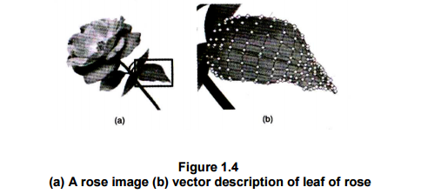
Difference between bitmap and vector
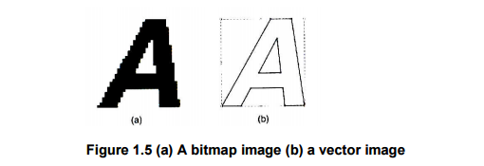
- DISPLAY DEVICES

- CRT(Cathode Ray Tube)
is one of the mostly used display technology. In CRT, a beam of electrons emitted by an electron gun strikes on specified positions on phosphor coated screen after passing through focusing and deflecting systems.
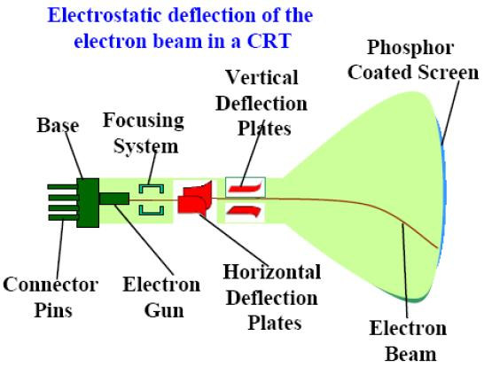
- The electron gun emits a beam of electrons (cathode rays).
- The electron beam passes through focusing and deflection systems that direct it towards specified positions on the phosphor-coated screen.
- When the beam hits the screen, the phosphor emits a small spot of light at each position contacted by the electron beam.
- It redraws the picture by directing the electron beam back over the same screen points quickly.
In CRT monitors there are two techniques of displaying images:
- Raster scan displays:
- A rectangular array of points or dots.
- In a raster scan system, the electron beam is swept across the screen, one row at a time from top to bottom.
- As the electron beam moves across each row, the beam intensity is turned on and off to create a pattern of illuminated spots.
- Picture definition is stored in memory area called the Refresh Buffer or Frame Buffer. This memory area holds the set of intensity values for all the screen points.
- Horizontal retrace:
- The return to the left of the screen, after refreshing each scans line.
- Vertical retrace:
- At the end of each frame (displayed in 1/80th to 1/60th of a second) the electron beam returns to the top left corner of the screen to begin the next frame.
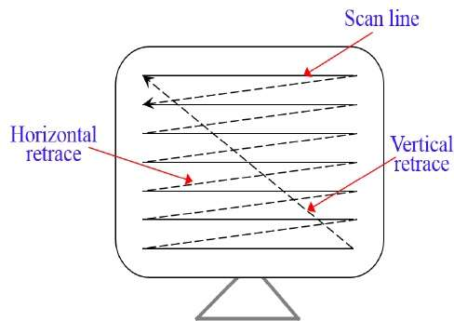
- Random scan display:
- In this technique, the electron beam is directed only to the part of the screen where the picture is to be drawn rather than scanning from left to right and top to bottom as in raster scan. It is also called vector display, stroke-writing display, or calligraphic display.
- Random scan display is the use of geometrical primitives such as points, lines, curves, and polygons, which are all based upon mathematical equation.
- In a random scan display, a CRT has the electron beam directed only to the parts of the screen where a picture is to be drawn.
- Picture definition is stored as a set of line-drawing commands in an area of memory referred to as the refresh display file.
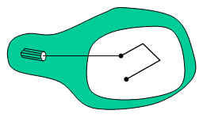

There are some parameters or properties related to graphic displays like CRT:
1. Persistence: Persistence refers to the property of a phosphor defining its life time, i.e., how long they continue to emit light after the CRT beam is removed.
2. Resolution: The maximum number of points that can be displayed without overlap on a CRT is referred to as the resolution. In other words, it is the number of points per unit length that can be plotted horizontally and vertically.
3. Aspect ratio: It is the ratio of the number of vertical points to the number of horizontal points necessary to produce equal length lines in both directions on the screen.
4. Frame buffer: Frame buffer also known as refresh buffer is the memory area that holds the set of intensity values for all the screen points.
5. Pixel: It refers a point on the screen. It is also known as pel and is shortened form of ‘picture element’.
6. Bitmap or pixmap: A frame buffer is said to be bitmap on a black and white system with one bit per pixel. For systems with multiple bits per pixel, the frame buffer is referred to as pixmap.
7. Graphical images: is used to add emphasis, direct attention, illustrate concepts, and provide background content.
- Two types of graphics:
(i) Draw-type graphics or vector graphics – represent an image as a geometric shape.
(ii)Bitmap graphics – represents the image as an array of dots, called pixels.

- LCD Display:
LCD (liquid crystal display) is the technology used for displays in notebook and other smaller computers. Like light-emitting diode (LED) and gas-plasma technologies, LCDs allow displays to be much thinner than cathode ray tube (CRT) technology.
- LCD stands for Liquid Crystal Display Organic molecules that remain in crystalline structure without external force, but re-aligns them like liquid under external force. So LCDs realigns themselves to EM field and changes their own polarizations.
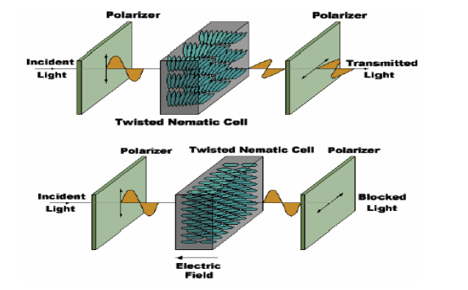
- LCDs are available to display arbitrary images (as in a general-purpose computer display) or fixed images with low information content, which can be displayed or hidden, such as preset words, digits, and 7-segment displays as in a digital clock.
There are two types of LCD
  - Active Matrix LCD:
- Electric field is retained by a capacitor so that the crystal remains in a constant state.
- Transistor switches are used to transfer charge into the capacitors during scanning.
- The capacitors can hold the charge for significantly longer than the refresh period.
- Crisp display with no shadows.
- More expensive to produce.
- Contains TFT (thin film transistor) technology to improve image qualities such as addressability and contrast.

  - Passive matrix LCD:
- It include n+m or n*m number of rows and columns, generation of each row simultaneously it generate the column pixels.
- LCD slowly transit between states.
- In scanned displays, with a large number of pixels, the percentage of the time that LCDs are excited is very small.
- Crystals spend most of their time in intermediate states, being neither "On" or "Off".
- These displays are not very sharp and are prone to ghosting.

- Plasma display:
- These are basically fluorescent tubes.
- A plasma display is a computer video display in which each pixel on the screen is illuminated by a tiny bit of plasma or charged gas, somewhat like a tiny neon light.
- Plasma displays are thinner than cathode ray tube ( CRT ) displays and brighter than liquid crystal displays ( LCD ).
- Plasma displays are sometimes marketed as "thin-panel" displays and can be used to display either analog video signals or display modes digital computer input.
Working of plasma
- Plasma contains two glass plates and millions of tiny cells in the form of xenon and neon.
- Each pixel on the screen is illuminated to provide plasma or charged gas like neon light.
- Display electrode are transparent and its surrounded by magnesium oxide and dielectric layer.
- The rear glass plate which contains address electrode of each cell is placed behind.
- Whenever the collision between ions and electrons they emit photon light.
- Each pixel contains composite colored sub-pixel (red, green, blue) mixture of these three colors we get different colors

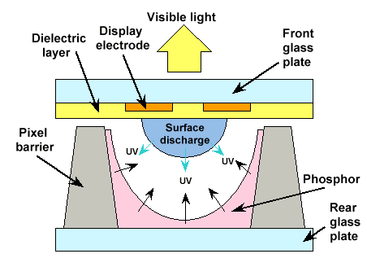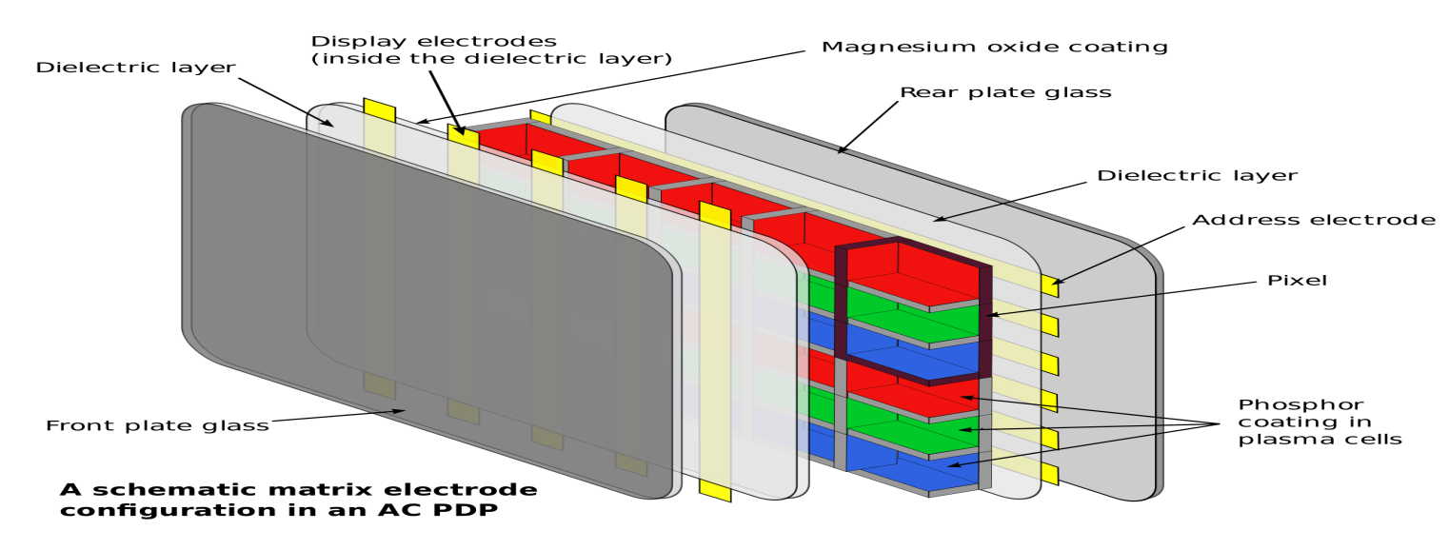Advantages:
- Slimness, a plasma display is flat rather than slightly curved as a CRT display is and therefore free of distortion on the edges of the screen.
- Unlike many LCD displays, a plasma display offers a very wide viewing angle.
- Larger screen size availability.
- Better contrast ratio and ability to render deeper blacks.
- Better color accuracy and saturation.
- Better motion tracking (little or no motion lag in fast moving images).
Disadvantages:
- Plasma Displays are more susceptible to “burn in” or “screen burn” of static images.
- Plasma Displays requires more power thus more heat produced than LCDs.
- Does not perform as well at higher altitudes.
- Shorter display life span than LCD. This can vary according to other environmental and use factors.

- THREE BASIC ELEMENTS FOR DRAWING IN GRAPHICS ARE:
- Point: A point marks a position in space. In pure geometric terms, a point is a pair of x, y coordinates. It has no mass at all. Graphically, however, a point takes form as a dot, a visible mark.
- Line: A line is an infinite series of points. Understood geometrically, a line has length, but no breadth. A line is the connection between two points, or it is the path of a moving point. A line can be a positive mark or a negative gap. Lines appear at the edges of objects and where two planes meet.
- Plane: A plane is a flat surface extending in height and width. A plane is the path of a moving line; it is a line with breadth. A line closes to become a shape, a bounded plane. Shapes are planes with edges.

- COORDINATE SYSTEM OVERVIEW
To define positions of points in space one requires a coordinate system. It is way of determining the position of a point by defining a set of numbers called as coordinates. There are different coordinate systems for representing an object in 2D or 3D.
1 .Cartesian coordinate system:
It is also known as rectangular coordinate system and can be of two or three dimensions. A point in Cartesian coordinate system can be defined by specifying two numbers, called as x – coordinate and the y – coordinate of that point.
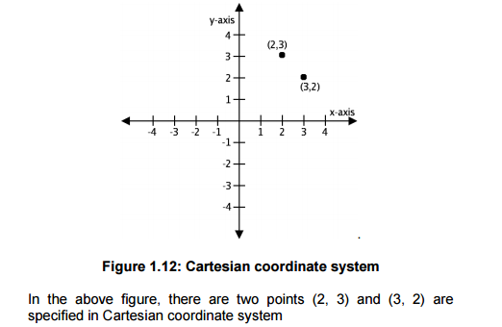
2. Polar coordinate system:
In polar coordinate system, the position of a point is defined by specifying the distance (radius) from a fixed point called as origin and the angle between the line joining the point and the origin and the polar axis (horizontal line passing through the origin).
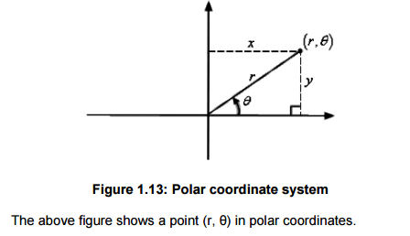
- INPUT TECHNOLOGY
  - Touch Screens
  - Light pen
  - Graphic tablets

